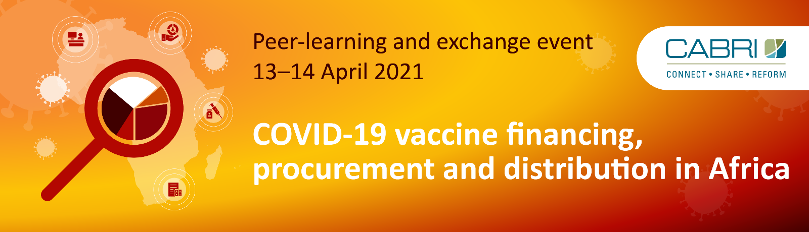
Programme
Vaccination against COVID-19 is a critical measure, indeed the single most efficient measure, to mitigate against loss of lives and further economic disruption. While the international community has made significant contributions towards financing the vaccine in African countries, there remains a significant financing gap to be filled through domestic resource allocation. It is consequently crucial that African governments consider ways in which to independently finance and distribute this new vaccine in both the short and medium term. This workshop will provide an opportunity for officials from ministries of finance and health to learn from peer countries and experts about financing, costing, budgeting and implementing COVID-19 vaccine programmes.
Tuesday, 13 April 2021 (10:00 – 14:30 GMT +2)
10:00 – 10:20 | Short video on housekeeping rules for the event  Welcome and opening remarks by Neil Cole (Executive Secretary, CABRI)  Programme overview by Danielle Serebro (Acting Programme Manager, CABRI)
Session 1  10:20 – 11:20 | Panel discussion: The economic case for vaccinating against COVID-19  There is increasing recognition that the societal benefits of the COVID-19 vaccine are far greater than associated cost; it has been estimated that for every month without a vaccine, the African continent loses USD 13.8 billion in GDP. However, purchasing and implementing the vaccine is a costly exercise and comes at a time when African governments have even less fiscal space than usual. Many African governments are consequently relying exclusively on the development community to fund the COVID-19 vaccine; however, this is unlikely to be sufficient.  What trends have been observed in budgeting for the vaccine across the continent and what is required to convince policymakers that budgeting for the COVID-19 vaccine is a necessity when it may crowd out other priority expenditure?  Panellists:  Dr Daniel Gebre-Michael Burssa (Senior Advisor to the Minister of Health: Federal Ministry of Health, Ethiopia)  Dr Philipp Krause (Senior Advisor, CABRI)  Ahmed Kouchouk (Vice Minister of Finance for Fiscal Policies & Institutional Reform, Ministry of Finance, Egypt)  Gyude Moore (Senior Policy Fellow: Centre for Global Development)  Moderator: Fifi Peters (CNBC Africa)
11:20 – 11:25 | Comfort break
Session 2  11:25 – 12:30 | Costing and budgeting for a vaccine during a pandemic  While the costing exercise will typically be undertaken by the ministry of health, the ministry of finance must ensure these programmes are represented in the budget presented to parliament and that the different elements of the PFM system are sufficiently flexible and reliable to facilitate vaccine programme implementation. This requires close collaboration between ministries of finance and health, both before and after vaccine purchase, and access to and utilisation of accurate and comprehensive data.  An overview of COVID-19 vaccine costing in Africa and the introduction and deployment costing tool by Dr Raymond Hutubessy (Senior Economist: Immunization, Vaccines and Biologicals Department, World Health Organization)  Costing the COVID-19 vaccine programme in the Ministry of Health by Dr Shobha Hajarnis (Consultant, Principal Secretary’s Secretariat, Ministry of Health, Seychelles)  Ghana’s approach to COVID-19 vaccine costing and budgeting by Dr Alex Amankwah-Poku (Head, Budget Development and Reforms, Budget Division, Ministry of Finance of Ghana)  Q&A  Facilitator: Joana Bento (Programme Manager: Building Public Finance Capabilities, CABRI)
12:30 – 12:40 | Break
Session 3  12:40 – 13:35 | Financing for the COVID-19 vaccine  It is the responsibility of a ministry of finance to carefully consider different financing options and the implications of each, both in the short- and medium-term. If the costs and benefits of financing decisions are not weighed prudently, scarce public resources will be consumed inefficiently, and vaccine programmes may not be effective in reaching herd immunity. While countries will have access to different financing sources, it is useful to consider all available options, including vaccine bonds, health taxes, debt swaps or debt relief, and budget reprioritisations.  Financing options for the COVID-19 vaccination programme by Danielle Serebro  A comprehensive financing mix for South Africa’s COVID-19 vaccination programme by Dr Mark Blecher (Chief Director: Health and Social Development, South African National Treasury)  Financing options under consideration in Mauritius by Parmanand Mawah (Acting Permanent Secretary: Ministry of Health and Wellness, Mauritius)  Q&A  Facilitator: Dr Philipp Krause
Session 4  13:35 – 14:30 | Break-away session: Day one reflections  In smaller group discussions, each participant will be asked to share their key take-aways from the day and how their country has approached costing, budgeting and financing for the COVID-19 vaccine.

Wednesday, 14 April 2021 (10:00-14:00 GMT+2)
10:00 -10:15 | Day one recap  Facilitator: Danielle Serebro
Session 5  10:15 – 11:15 | Vaccine procurement  On day one, we considered how governments can budget for and raise adequate financing to purchase the COVID-19 vaccine. However equally important is how governments can most efficiently and effectively procure vaccines and ensure value for money is attained. Governments have two main options to purchase the vaccine: direct or pooled procurement. During this session, we will learn more about how these purchasing options have been used and decided on during the current crisis, and how concerns around efficiency and accountability in procurement are approached during an emergency.  An overview of advanced purchasing commitments and the African Medical Supplies Platform by Chidinma Ifepe (Head of Operations: African Medical Supplies Platform)  Emergency procurement: balancing efficiency and accountability by Dr Diop Samba (Head of Regulatory and Legal Affairs at Regulatory Authority on Public Procurement of Senegal)  Q&A  Facilitator: Fréjus Lingue (PFM Specialist: CABRI)
11:15 – 11:20 | Poll results
11:20 – 11:30 | Comfort break
Session 6  11:30 – 12:45 | Ensuring effective roll out  Dr Kwaku Agyeman Manu, Minister of Health, Ghana, has noted “As we’ve learned with routine immunisation vaccines don’t save lives, vaccination does. This means we need the health infrastructure in place - from supply chain and logistics to well-trained health workers - to ensure the effective and streamlined distribution of vaccines”. According to the WHO’s Vaccine Readiness Assessment Tool (VIRAT) based on countries’ self-reporting, Africa as a region scores 33 percent readiness for a COVID-19 vaccine roll-out, far below the benchmark of 80 percent. Furthermore, only 24 percent self-reported to have adequate plans in place for resources and funding of the roll out.  Financing for vaccine roll outs, particularly “last-mile” distribution, has traditionally been neglected by both development partners and policy makers and it is critical that this mistake is not made for the COVID-19 vaccine. In this session, we will look at how countries can cost and budget for the roll-out, utilise the private sector and NPOs, and ensure funds flow efficiently to service-delivery centres.  Findings of scoping review on PFM & vaccine roll out by Dr Hélène Barroy (Senior Public Finance Expert: Department of Health Systems Governance and Financing, World Health Organization)  Planning for the COVID-19 vaccination programme roll out in Nigeria by Dr Bakunawa Garba Bello (Senior Medical Officer in Disease Control and Immunization Dept of National Primary Healthcare Development Agency (NPHCDA)) (alternative Ministry of Health, Rwanda)  Q&A  Facilitator: Dr Biniam Bedasso (PFM Specialist: CABRI)
12:45 – 13:00 | Concluding remarks by Neil Cole (Executive Secretary, CABRI)

https://reliefweb.int/report/world/remarks-world-bank-group-president-david-malpass-virtual-meeting-africa-covid-19
https://www.who.int/news/item/18-12-2020-covax-announces-additional-deals-to-access-promising-covid-19-vaccine-candidates-plans-global-rollout-starting-q1-2021
https://news.un.org/en/story/2020/11/1078642

