

SOCIAL SERVICES
From: Rezah Atcha
Tel: (012) 315 5287
Ref: SL2/5/1-2006/07

DIRECTORATE: NATIONAL BUDGETS

REPORTING ON 2006/07 EXPENDITURE: MARCH

- Overall Spending
  - The report on spending for the Department of Health is summarised below:

Table 1:
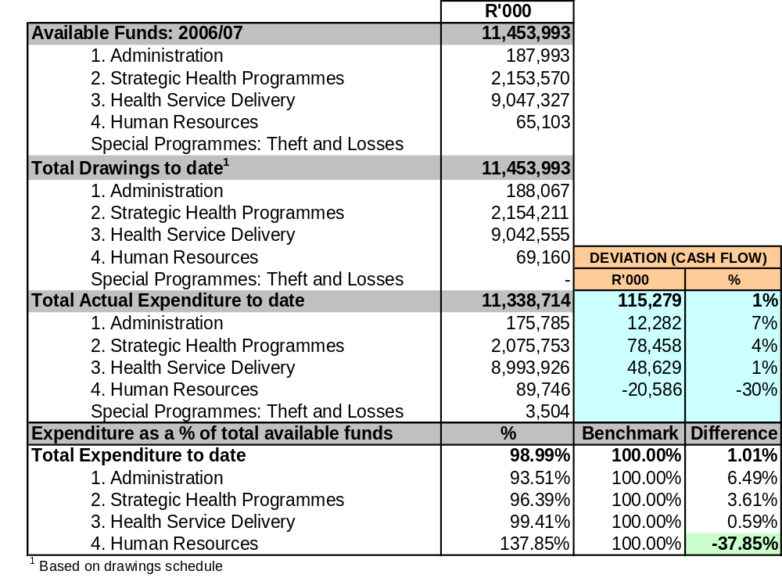

  - The department spent 98.99% of its budget at the end of 2006/07. However, this may change as the department journalises entries before submitting their financial statements to the AG on 31 May 2007.

  - When comparing expenditure to the department’s drawings, 1.01% of drawings was retained at the end of 2006/07, which is R115,279m in value. This is more than the R93,717m predicted over the past few months (R21,562m more, or 23%). Funds still have not been shifted as yet to cover the over spending in programme 4 (due to the purchase of the Human Resource software for Health documented in earlier reports), although discussion with the department revealed that authorisation has been received and the journalising of entries will occur before the submission of financial statements.
  - Expenditure on programmes 1, 2 and 3 were within the 8% variance. However, these figures may change as the department allocates some of the over expenditure on programme 4 to these other programmes.
  - Programme expenditure figures for March in the IYM vary slightly from those in Vulindlela for the same period. As mentioned, many journal entries have been and are currently being made. Therefore, this IYM would differ from Vulindlela, and will also differ from the department’s final AFS.

- Spending by Economic Classification
Table 2:
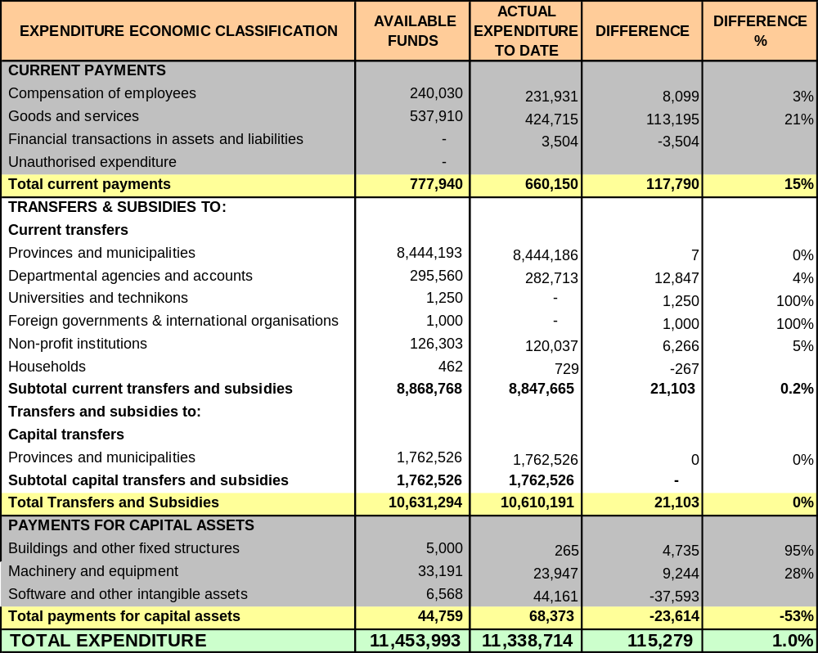
  - The economic classification analysis reveals that the R115,279m under spending consists of R117,790 for goods and services, R21,103m for transfers and an overspend of –R23,614 on capital assets. Analysis on Vulindlela revealed that “available funds” still exist in goods and services for:
- Advert for tenders for the GAAP (R56m out of a budget of R60m)
- R16m for membership fees for the UN Global AIDS and Health Fund
- R11.8m for printing costs for the HIV and AIDS directorate. This should balance off with R22m overspending on “advertising” on the GAAP plan in the same directorate
- R5m on computers <R5000
- R4m on consultants
- R4m on travel and subsidence

It is surprising that only a tiny portion (R563 000) of this amount was attributed to condoms, as just last month the department was predicting a R30m saving on this item. This also implies that the department did not reveal other potential areas of under expenditure, given that the overall under spending is still roughly the same as predicted last month. However, the total goods and services figure should reduce once funds have been shifted to cover the over expenditure on capital assets.

  - The under spending under transfers and subsidies can be summarised as follows:
    - The under spending on transfers and subsidies includes R9.8m for a transfer to the NHLS. According to the department, the documentation for the transfer for March 2007 was completed and sent off, but was not received by the relevant party. By the end of March, no one had noticed this error, and by the time the mistake was realised, it was too late to make a payment. A payment was eventually made in April 2007 out of the 2007/08 budget. The department is to request a rollover for this amount.
    - There is also under spending items on transfers to universities (R1,250m), Palestine (R1m) and to non-profit institutions (R6,266m). However, these items will probably be cleared once the journalising of items is completed.

  - The department under spent by R8m saving on compensation of employees. This should be viewed as a red flag, as Health is currently negotiating with National Treasury for R140m to build a new tower for their Civitas building, with the motivation that it plans to employ 800 new employees (from around 1,200) in the next few years.
  - The department over spent by R23,614m on payments for capital assets, due to the purchase of the Human Resource Software package for R41m. There was under spending of R5m of that for Johannesburg Labs, and R4,350m for specialised capital equipment for laboratories which will only be delivered in March 2007. Underspending on machinery and equipment is R4,734m more than predicted last month. Analysis on Vulindlela revealed that this was for office building, under the corporate services sub-programme. Consultation with the department has revealed that permission has been granted for the virement of funds to compensate for the over expenditure on capital assets.

- Spending on Earmarked Funds
Table 3:
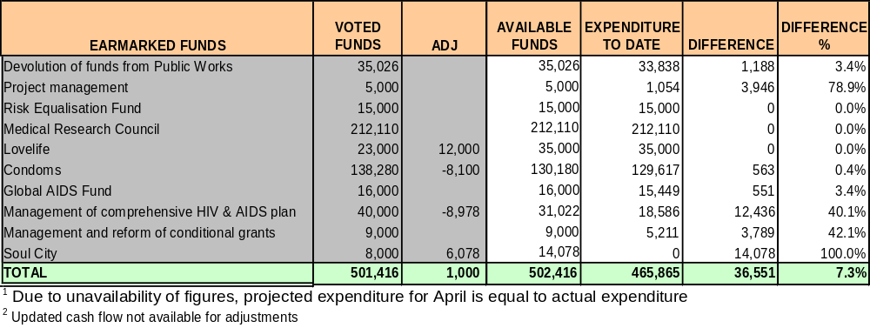

  - As mentioned earlier, it is surprising that the department managed to spend almost its entire budget on condoms. This is probably due to the receiving of outstanding invoices, which the department predicted would arrive in August 2006. Analysis on vulindlela revealed that the department under spent on female condoms by R12,047m, and overspent on male condoms by R11,483m (overall under spending of R563).
  - The expenditure for project management is highly disappointing, with 78.9% of funds retained. This fund was to build administrative capacity within the department, which has been a weakness for some time.
  - The problems with the cash flow for Soul City were documented in earlier reports. Consultation with the department revealed that payments were made to Soul City using donor funds, and the department is in the process of claiming this money back. This should reduce the under spending.

- Suspense Accounts
Graph 1:
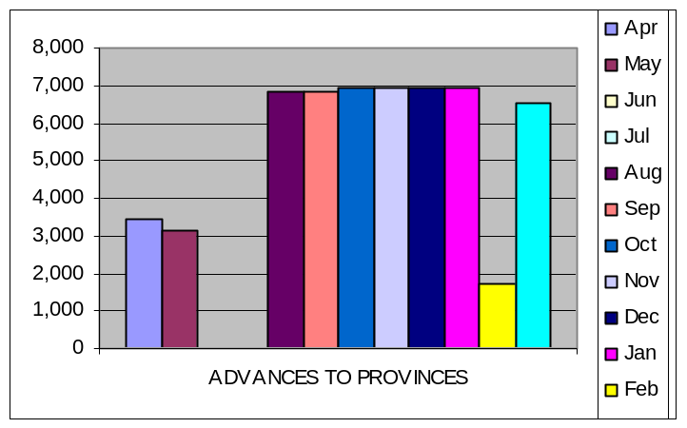
  - Advances to provinces closed at R6.5m for the year. These funds are submitted to the department of Foreign Affairs on behalf of the provinces for Havana students. Once proof has been received that the Cuban government has been paid (via Foreign Affairs), the account is then cleared. There are therefore delays in clearing the accounts. The balance indicates that the Cuban doctor accounts have been cleared, while the R1.7m is for Gauteng Health for media-related work.

Graph 2:
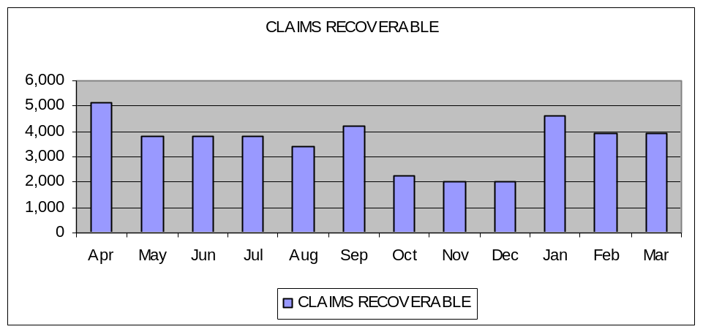

  - Claims recoverable closed at R3,914m for the year. This, according to the department is due to funds owed to the department of Health from other departments. It is small amounts from numerous departments as opposed to a few large amounts from a few departments. It also contains salary claims for DOH employees who have transferred to provinces. A request had been made telephonically for the department to provide more detailed information regarding these claims, but this has not been received.

Graph 3:
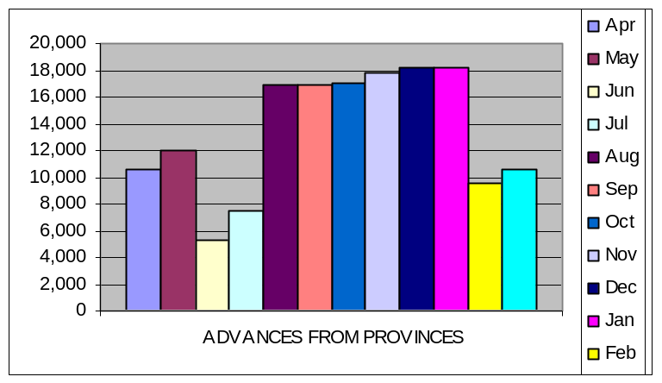

  - Advances from provinces closed at –R103.553m for the period. These funds are mainly from provincial departments for donations for doctors from Cuba, which the National department then pays to Havana. These are used for inter alia running costs and air tickets. Confirmation has to be received from the department of Foreign Affairs that the Cuban government has been paid, resulting in delays in clearing accounts.
  - The total balance of the suspense accounts as at the beginning of August 2006 is –R126 000. In a worst case scenario claims (advances to provinces and claims recoverable) will amount to R10.4m, which does not indicate a threat of a charge to the state in light of the departments under spending.

- Revenue
  - The department collected R5,122m in revenue, which is slightly less (about 12%) than the original prediction of R5,8m at the beginning of the financial year after some higher forecasts in the preceding months. Most revenue will emanate from sales of goods and services (mostly licensing fees), followed by financial transactions in assets and liabilities.

Graph 4:
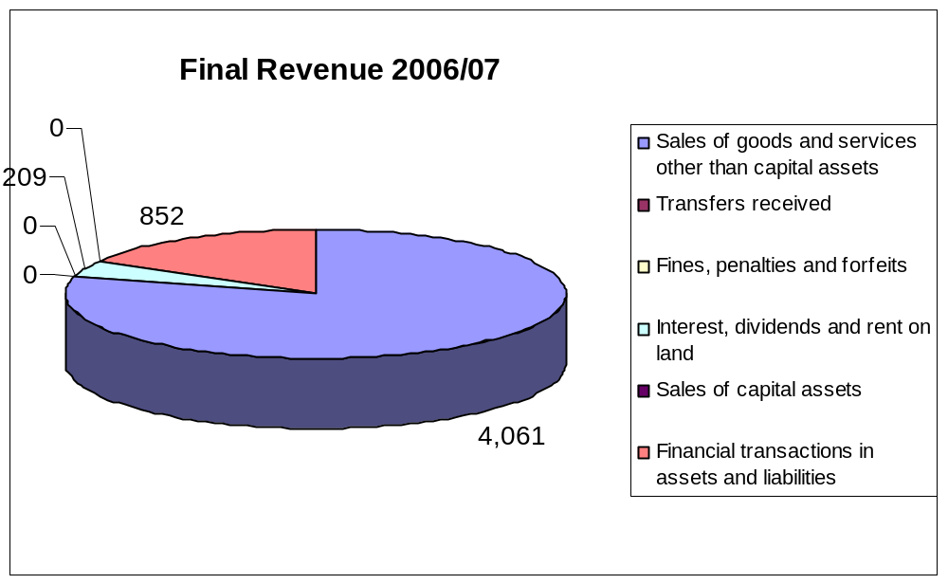

- Human Resources
  - The department shows a vacancy rate of 26.7% for the month of March.
  - Senior management still shows very high vacancy rates (35% for Chief Directors, 22.5% for Directors). Failure to appoint staff could jeopardise the department’s ability to manage its growing policy duties e.g. the NSP for HIV and AIDS, the new remuneration dispensation for Health professionals etc.

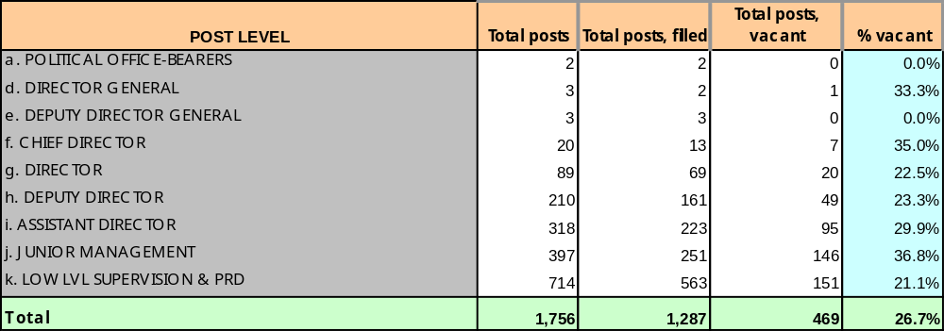

APPENDIX 1: DRAWINGS VS. ACTUAL EXPENDITURE UP TO MARCH 2007



